ECE 874 **Test 1 Out-of-Class Component** Name ______________________

(20 points total)

Instructions:

1. The test is due on Wednesday February 12 before the start of class at 11:15AM.
2. You must show all steps in your solutions
3. Your exam solutions are to be your own work, you are not to give or receive assistance of any kind on this exam.





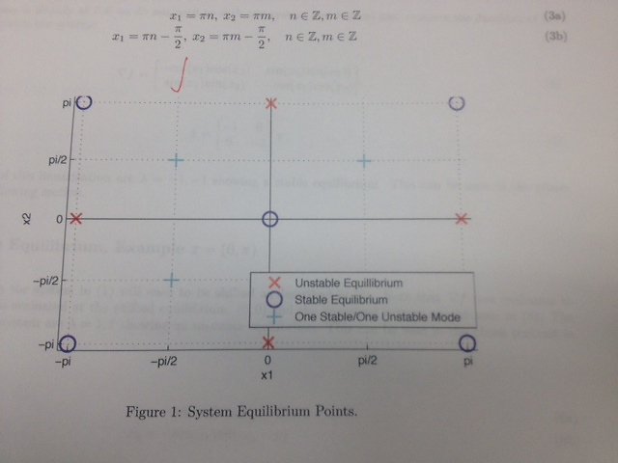

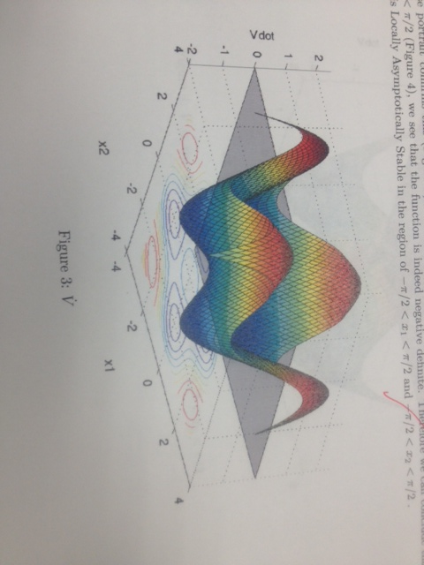

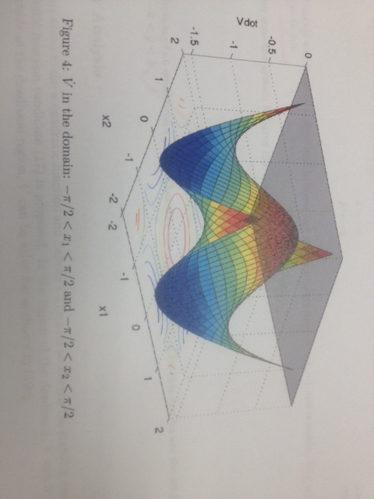

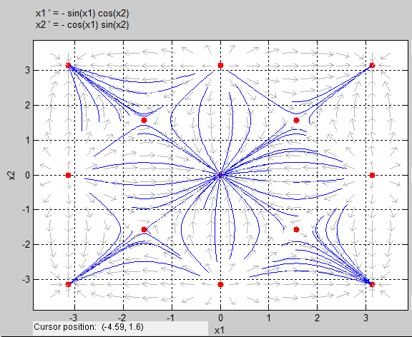

(pi/2,pi/2)

(pi,0)

(pi,pi)

(0,pi)

(0,0)



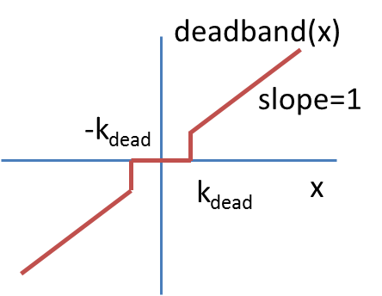

Define the following MATLAB function in the pplane8.m directory to calculate deadband().

function y=deadband(in1,kdead)

if abs(in1)<kdead

in1=0;

end

y=in1;



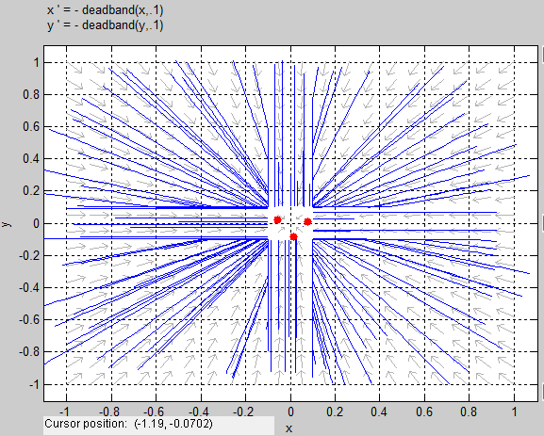

N=E:Vdot(x)=0

M:V(x)<c and Vdot<=0